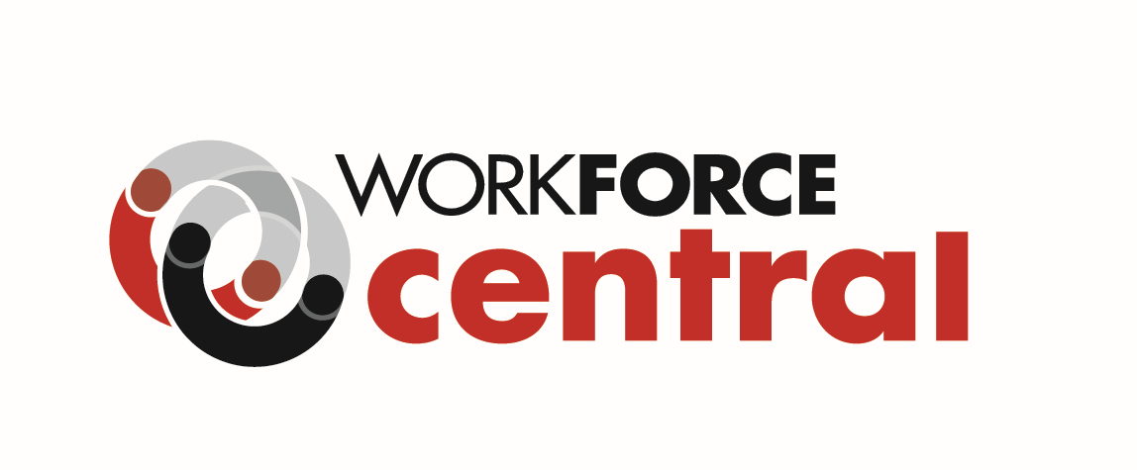

REQUEST FOR QUALIFICATIONS AND QUOTES

Equity Capacity Building and Consulting
RFQQ# EQUITY CONSULTING-4-20-2021

WorkForce Central issues this Request for Qualifications and Quotes (RFQQ) on behalf of the Pierce County Workforce Development Council to identify and select qualified individual(s) or organization(s) to provide consulting, facilitated learning, and coaching focused on organizational recommendations from the first phase of WorkForce Central’s equity and anti-racism work. Please see specific information about desired services in the Equity Consulting RFQQ, posted at RFQQ: Equity Consulting Services – WorkForce Central (workforce-central.org).

Any contract(s) for services resulting from this RFQQ will be funded to a maximum of $50,000 for a single or multiple contracts awarded. Services are anticipated to begin on or near May 17, 2021, and end by June 30, 2022.

Key Dates
- RFQQ Release: April 20, 2021
- Responses Due/Closing Date: May 4, 2021, before 5:00 PM PDT
- Award Announcements: On or near May 7, 2021

Questions are welcome and can be emailed to Procurement@workforce-central.org. Please include “RFP# EQUITY CONSULTING-4-20-2021 in the email subject line.

