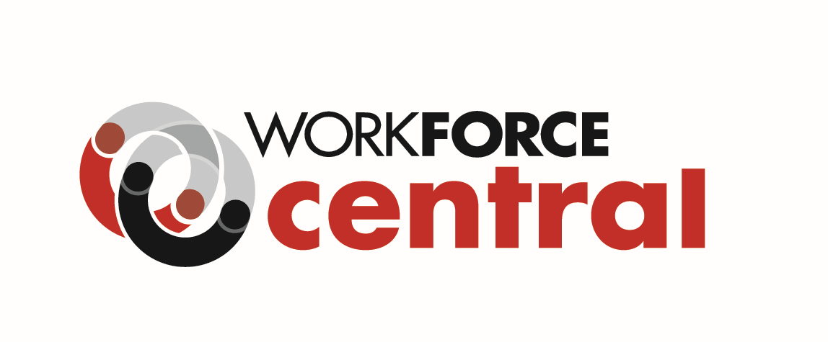

REQUEST FOR QUALIFICATIONS AND QUOTES

Industry Skills Cohort Trainings
RFQQ# Industry Skills Cohort Trainings - 8-12-2021

WorkForce Central is seeking qualified organizations to provide employer-driven, rapid reskill-upskill training delivered to cohorts of participants. This training will prepare individuals to enter living-wage employment in the industry, occupation, and skill development pathways identified as local employer priorities in the RFQQ.

Cohort training resulting from this RFQQ will occur between January 2022 - December 2025. WorkForce Central’s goal is to build a pool of cohort training providers, enabling timely response to employers’ reskill-upskill training needs as they arise over the next three years. We anticipate funding multiple providers and training cohorts during this time period, and the total funding that may be awarded is not yet established. There is no set limit to the amount that may be requested per training; proposed budgets will be assessed based on reasonable cost comparisons, with awareness that costs will vary between training programs.

Because training contracts will be funded by Workforce Innovation and Opportunity Act (WIOA) Title 1 funds, all training participants must be eligible for WIOA Title 1 services. Ideal respondents will demonstrate previous success with and a plan for training WIOA-eligible individuals, those who belong to communities of color, individuals impacted by poverty, veterans and military spouses, individuals with disabilities, and additional populations facing systemic barriers to employment.

Additional information and the full RFQQ can be viewed at WorkForce Central - Cohort Trainings RFQQ

Key Dates
- RFQQ Release: August 12, 2021
- Proposals Due/Closing Date: September 29, 2021, before 5:00 PM PDT
- Award Notification: On or near November 8, 2021

Questions are welcome and can be emailed to Procurement@workforce-central.org. Please include “RFQQ# Industry Skills Cohort Trainings - 8-12-2021” in the email subject line.

